OWASP JUICE SHOP - DIAGRAM

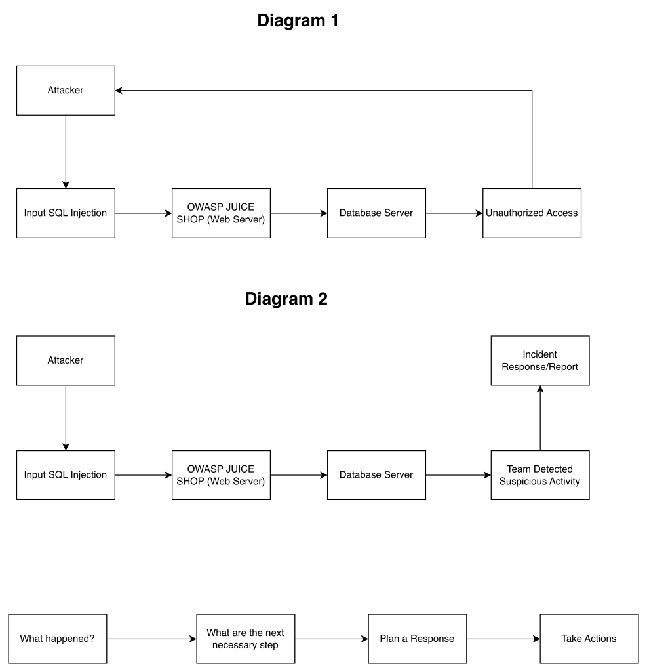

Diagram 1

The attacker is trying to get information from the system without permission. The attacker types the malicious SQL code into the input box. The website server receives the attacker's input and then sends it to the database. The database stores all website data, which includes sensitive information. The attacker gains access to the data from the database, and the attacker is now able to see sensitive information. This includes usernames and passwords. The security team has to take action quickly to see which information the attacker was able to get and which users were infected.

Diagram 2

Attacker- The attacker is trying to get information from the system without permission, trying to see if the system is able to take action quickly. The attacker types the malicious SQL code into the input. The OWASP Juice Shop server receives the attacker's input. The malicious code through and now the malicious code is sent to the database server. The database server stores very important information from website data. Some of the information can include usernames and passwords. The security team detected suspicious activity within the system, and they noticed strange access attempts. The security team now investigates the attack to see if there was any damage or loopholes in the system. Report the incident to the whole team. Lastly, they take action to secure the system and prevent future incidents like this one.

